ASSIGNMENT SUBMISSION COVER SHEET

Cse25-303
Student Id:

Oteng Monameng
Student names:
Cse25-303@thuto.bac.ac.bw
Student email:

Cohort: 2026

SCIS WMD_2026 A01
Assignment title:

20-03-2026
Date of submission:
Computer System Engineering
Programme of Study:

YEAR 1
Year of Study:

Intellectual property statement
By checking the box below, I certify that this assignment is my own work and is free from plagiarism. I understand that the assignment may be checked for plagiarism by electronic or other means and may be transferred and stored in a database for the purposes of data-matching to help detect plagiarism. The assignment has not previously been submitted for assessment in any other unit or to any other institution. I
have read and understood the Botswana Accountancy College plagiarism guidelines policy.
☐ Agree Signature…O.Monameng………………………………….
Date…………20-03-2026……………………………….

WEBSITE SPECIFICATIONS

INTRODUCTION
Monameng Security Company provide security services to safeguard people, property and assets from threads, violence or vandalism. The company offer comprehensive security solutions like CCTV installation, armed response, access control, and alarms to commercial and residential clients. The website represents Monameng Security Company online, build credibility and reach potential clients in a competitive market.

WEBSITE OBJECTIVES
Establish a professional and trustworthy online presence that accurately represents Monameng Security Company services, name, and values. This website also aims to educate visitors about security solutions and makes it easy to find details on CCTV, armed response, access control, and alarms so they can apply for services that they understand. The website should provide online application process so visitors can request a service directly from the website.

WEBSITE GOALS
- Increase organic traffic by 20% in the first 3 months SEO.
- Convert visitors into clients by “Apply Now” buttons on every service page and maintaining a dedicated Apply page with a user-friendly form.
- Achieve at least 15 completed service applications per month after launch.
- Organize navigation so any services or application can be reached within two clicks.
- Ensure the website is fully responsive and loads quickly.
- Display contact details in the footer and include a Feedback page for testimonials.

TARGET AUDIENCE

PRIMARY AUDIENCE
BUSSINESS AND ORGANISATION
Company that requires security services to protect their premises, employees and assets.
They usually require large-scale and long-term security services.

DEMOGRAPHICS:
Age = 25 to 60 years.
Gender = Males and Females.
Occupation = Business owners and managers
Income = Have high income and can afford security services.
Location = Global

TECHNICAL APTITUDE:
Moderate to high: Most Business use tables and computers at work to send emails, fill forms and navigate through the internet so since they interact with computers on a daily basis so their technical aptitude is moderate to high.

GOVERNMENT INSTITUTIONS:
Public sector organizations that require security services for facilities and operations.
Also require large-scale and long-term security services.
DEMOGRAPHICS:
Age = 30 to 60 years
Occupation = government officials
Gender = Male and Female
Location = Local (Botswana)
TECHNICAL APTITUDE
Moderate to high: Government institutions usually have Information Technology departments that are familiar with the internet and solve computer problems and can handle more complex systems or cloud-based platforms.

SECONDARY TARGET AUDIENCE

EVENT ORGANISERS:
Individuals that need security services for event and usually need fast response to controlling crowd and event security personnel.
DEMOGRAPHICS:
Age = 20 to 50 years
Gender = Male and Female
Occupation = Event planners and coordinators.
Location = Local (Botswana)
TECHNICAL APTITUDE:
Moderate: Event organizers communicate and book with artist on the internet also send and receive emails through the internet so their level of aptitude is moderate.

INDIVIDUALS
Home owners that need security services for their home and families for affordable prices, for example alarms and CCTV.
DEMOGRAPHICS:
Age = 25 to 80 years
Gender = Male and Female
Income level = Middle to High
Location = Global
TECHNICAL APTITUDE:
Basic to High: People use personal computers and smart phones to browse the web and use social media applications to communicate so they at least know the basic of the internet.
There are other users who are advanced in terms of technical aptitude as some are programmers and Developers hence deal with the internet on a daily basis.

TYPE OF WEBSITE
BUSSINESS WEBSITE
This website aim is to represent Monameng Security Company online and build a professional brand image of the Company online.
Monameng security services website aim to promote security services offered by the company.
This website will let users apply for services offered by the company.
The website will present information, services, past projects and a contact form.
This website will educate visitors on types of services and their importance that are offered by the company.

INFORMATION DESIGN AND TAXONOMY

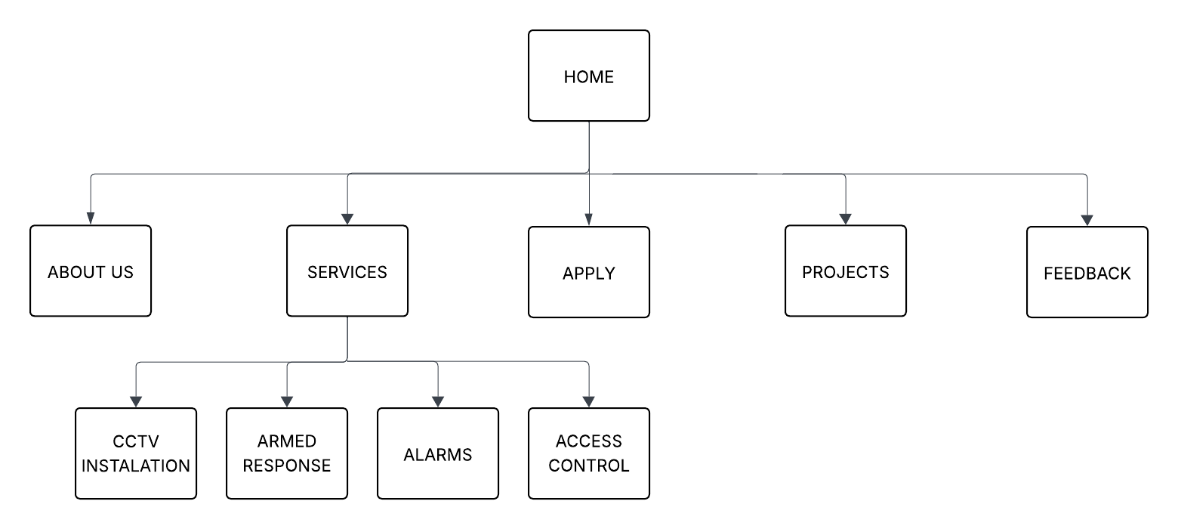
The Monameng website will have 10 pages and those pages will be Home page, about us, Services, Apply, and Project and Feedback pages also it will contain CCTV installation, armed response, access control and alarms pages under services.
HOME PAGE
- The home page consists of company name, a company description, logo, and navigation to other pages.
- This involves the Header that consists of company name, logo, and navigation to other pages.
- The main section will consist of the company description and direct link to apply.
- This involves the Footer that consist of contact, copyright information and privacy
ABOUT US
- It has Company Profile, mission and values, and contacts.
- The Header consists of navigation to other pages.
- The main section consists of company profile, and mission and values.
- This involves the Footer that consist of contact, copyright information and privacy.
SERVICES
- Contains services that the company offers
- The Header consists of navigation to other pages.
- The main section has CCTV installation, armed response, access control, alarms services and a direct link to Apply.
- This involves the Footer that consist of contact, copyright information and privacy.
PROJECTS
- It will have recent Installations.
- The Header consists of navigation to other pages.
- The main section has information like recent Installation and current big projects.
- This involves the Footer that consist of contact, copyright information and privacy.
FEEDBACK
- Consists of client’s testimonials about the services offered by the company.
- The Header consists of navigation to other pages.
- The main section has the form that allow the clients to give feedback about services offered by the company
- This involves the Footer that consist of contact, copyright information and privacy
CCTV INSTALLATION
- Contains detailed information about CCTV installation services
- The Header consists of navigation to other pages.
- The main section contains CCTV installation like explanation, importance, features and how the service works and a direct link to Apply.
- This involves the Footer that consist of contact, copyright information and privacy
ARMED RESPONSE
- Contains more detailed information about armed response service.
- The Header consists of navigation to other pages.
- The main section about armed response like explanation, benefits, how the service work and coverage age and a direct link to Apply.
- This involves the Footer that consist of contact, copyright information and privacy
ACCESS CONTROL
- Contains detailed information about access control
- The Header consists of navigation to other pages.
- The main section has access control explanation, importance, features and how the service works and a direct link to Apply.
- This involves the Footer that consist of contact, copyright information and privacy
ALARMS
- This page contains detailed information about the alarm services
- The Header consists of navigation to other pages.
- The main section has alarm services explanation, importance, features, types of alarm system and how the service works and a direct link to Apply.
- This involves the Footer that consist of contact, copyright information and privacy
APPLY
- This will contain a form that will let users fill in their information and apply for a service of their choice.

TECHNICAL BRIEF
I will develop Monameng Security Company using the following technologies and tools.
- HTML5 – Use HTML to write the website code.
- CSS3 – Use CSS3 to style Monameng Security Company using CSS3.
- Bootstrap 5 – Use Bootstrap 5 to make my website responsive.
- JavaScript (ES6) – To make the website interactive JavaScript will be used.
- Visual Studio Code – Use of Visual Studio Code as a text editor to code my website.
- Git and GitHub – Used to manage track changes of the website document
- GitHub pages – To host Monameng Security Company website.
- Canva – To make social media cards and graphics for Monameng Security Company.
- GIMP – To create and optimize logos and also service images for Monameng Security Company.

